MLOps Internal Assessment – 1

Member1: Niyati Trivedi (25MDS015)
Member2: Hena Patel (25MDS010)
Topic: Air Home Price Prediction using ML

Flow of Project

Step 1: Data Preparation
- Collected Air Home dataset consisting of features:
  - Budget
  - Location
  - Number of Bedrooms
  - Number of Bathrooms
  - Square Footage
  - Property Type
  - Year Built
- Pre-processed the data:
  - Handled missing values.
  - Converted categorical columns (Location, Property Type) using encoding.
  - Scaled numerical features.
  - Split dataset into training and testing sets using train_test_split.

Step 2: Model Training
- Trained a Regression model (Random Forest / Linear Regression) on the dataset.
- Calculated the Mean Squared Error (MSE), R2 Score
- Saved the trained model as air_home_price_model.pkl using joblib.

Step 3: Database Setup
- Created a PostgreSQL database to store:
  - Input features (location, bedrooms, bathrooms, sqft, property type, year built)
  - Predicted rating
  - Timestamp
- Database runs on Port 5432 (fallback 5433 if needed).

Step 4: API Creation
- Used FastAPI to create backend service.
- Defined the following routes:
  - /health → To check if the API is running.
  - /predict → Accepts JSON input, runs ML model, returns prediction.
  - /history → Returns prediction history.
- Implemented error handling for model not loaded and invalid inputs.

Step 5: UI Creation
- Created a Flask-based UI serving index.html.
- UI features:
  - Input fields for location, bedrooms, bathrooms, sqft, property type, year built
  - Predict button to call /predict API
  - Display prediction house price dynamically
  - Load prediction history from /history API
- Used JavaScript fetch API to communicate with backend.

Step 6: Containerization
- Each module containerized separately using Docker:
  - ml_module → Trains or serves the Air Home model
  - backend → FastAPI service
  - ui → Flask-based UI
  - database → PostgreSQL
- All services orchestrated using docker-compose.

- Version Control

- Master – Consisted of final tracked changes after successful
testing on individual branch
- Niyati – Execution carried by Member – 1. Merge the branch only
when all modifications are working correctly without errors.
Until then commit on respective branch only.
- Hena – Execution carried by Member – 2. Merge the branch only
when all modifications are working correctly without errors.
Until then commit on respective branch only.

2. Folder Structure
airhome_mlops_project/

├── backend/
│ ├── app.py
│ ├── Dockerfile
│ └── requirements.txt
│
├── ml_module/
│ ├── train_model.py
│ ├── air_home_price_model.pkl
│ ├── Dockerfile
│ └── requirements.txt
│
├── database/
│ ├── init.sql
│ └── Dockerfile
│
├── ui/
│ ├── app.py
│ ├── index.html
│ ├── Dockerfile
│ └── requirements.txt
│
├── docker-compose.yml
├── data/
│ ├── raw/
│ └── processed/

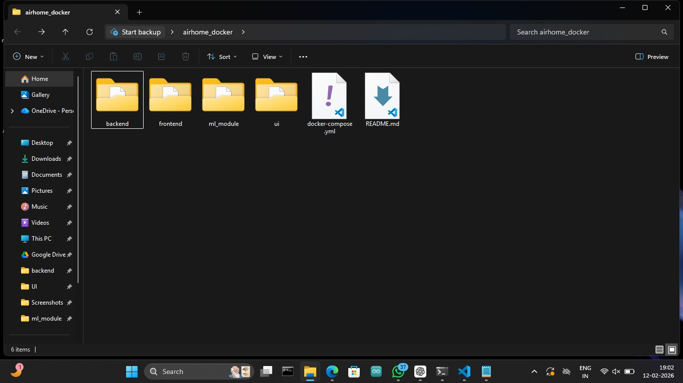

2.1 Libraries Used
Module | Libraries
Backend | fastapi, uvicorn, joblib, pydantic, psycopg2-binary
Frontend | flask
ML | scikit-learn, numpy, pandas, joblib
Database | postgreSQL

2.2 Modules
- ML Module: Trains Air Home price prediction model and saves air_home_price_model.pkl.
- Backend: Serve APIs /predict, /history, /health.
- Frontend: Flask app serving index.html for user interaction
- Database: PostgreSQL storing user inputs and predicted prices

3. Flowchart / Architecture
+----------------------+
| User Inputs |
| (Location, Bedrooms, |
| Bathrooms, Sqft, |
| Property Type, Year) |
+----------+-----------+
|
v
+----------------------+
| Frontend UI |
| (Flask + HTML) |
+----------+-----------+
|
v
+----------------------+
| Backend API |
| (FastAPI) |
| /predict |
| /history |
+----------+-----------+
|
v
+----------------------+
| ML Module |
| (Regression Model) |
+----------+-----------+
|
v
+----------------------+
| Database |
| (PostgreSQL) |
+----------------------+
Flow Description:
User enters Air Home property details on the UI.

UI sends POST request to backend API /predict.

Backend loads trained air_home_price_model.pkl.

Model predicts house price and returns result as JSON.

Backend stores inputs and prediction into PostgreSQL database.

UI displays predicted house price to the user.

- Errors Encountered and Solutions

Error | Cause | Solution
Model not loaded | Wrong path or missing model file | Ensured correct volume mounting and file path
Categorical encoding mismatch | Training and prediction encoding different | Saved encoder using joblib and loaded during prediction
Python version mismatch | Different sklearn version | Fixed sklearn version in requirements.txt
Backend 500 error | Database connection failure | Corrected database host name in docker-compose

Important Docker Commands Used

Command | Description
docker network create --driver bridge mlops-net | Create custom bridge network
docker network ls | List networks
docker compose up -d | Start all services in detached mode
docker compose up --build -d | Rebuild images and start services
docker ps | List running containers
docker logs <container> | Check container logs
docker exec -it <container> bash | Access container shell
docker rm -f <container> | Remove container manually

6. Steps to Run the Project
Build and run all services
docker-compose up --build
Open UI in browser
http://localhost:8501
Test Prediction
Enter Air Home details → Click Predict Price → View result
Check backend logs
docker logs airhome_backend

Conclusion
- Successfully implemented an end-to-end MLOps pipeline for Air Home Price Prediction using Docker.
- ML module, backend API, PostgreSQL, and UI run as separate services.
- Resolved issues related to model loading, encoding mismatch, and container networking.
- UI communicates with backend API via Docker network using service names.

Screenshots
